Zebrafish Fin Regeneration Virtual Experiment
By Jamie Nosbisch, Phyo Ma, Arthur Reynolds, and Sooji Katie Jo

The purpose of this experiment is to learn more about the process of regeneration and the molecular mechanisms behind tissue growth. Zebrafish are popular model systems for regeneration experiments due to the ease with which they can be maintained in a laboratory setting as well as their ability to quickly regenerate many body parts and organs. In this experiment, a hypothesis regarding regeneration will be tested by making measurements and observations on images of zebrafish caudal fins in the process of regenerating.

Background Information

Zebrafish are a useful model to study cellular regeneration in vertebrates due to their ability to reconstruct amputated organs and tissues including the heart, scales, caudal fin, retina, and spinal cord. Caudal fins are a common choice for studying regeneration, particularly for students, because of their easy accessibility, fast regeneration rate, and relatively simple structure. Zebrafish caudal fins are composed of segmented bony rays, inter-ray mesenchymal tissue, and enclosing epidermal tissues. Each fin ray is composed of two hemirays and an inner space filled with intra-ray mesenchymal cells (Fig.1). These bony rays are made from bone matrix secreted by osteoblasts.

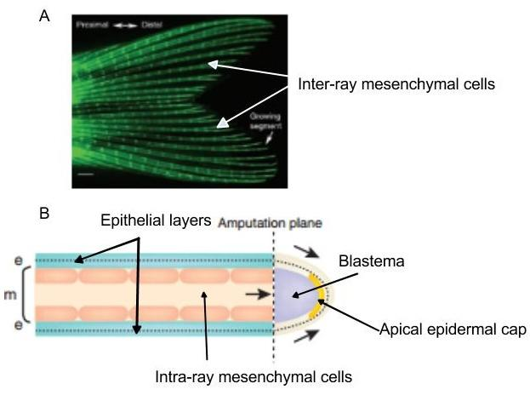
Figure 1: The anatomy of the zebrafish caudal fin and detailed cartoon of each fin ray. (A) Zebrafish caudal fin stained with calcein so that fin rays are visible. (B) Cartoon of a longitudinal section of a single amputated fin ray. Cells from epithelium layers (blue) move to cover the amputated area, and form the epidermis (side arrow) and apical epidermal cap (AEC). The intra-ray mesenchymal cells also move toward the amputated area (middle arrow), and form immature blastema (purple). (Iovine 2007)
When a caudal is damaged due to a cut or an attack from other organisms, it takes about two weeks to regenerate a fully functioning fin. Once the fin is cut, the epithelial cells migrate to cover the wounded area. After approximately one day, the apical epidermal cap (AEC) is formed at the amputated area. Under the apical epidermal cap, a mass of undifferentiated mesenchymal cells accumulate and form a blastema. Within 48 hours of the amputation, the cells in the blastema start to differentiate and construct the original tissue structure.

Now that we have some background information on zebrafish caudal fin regeneration, let’s look at the hypothesis we are going to test in this virtual fin clip regeneration experiment.

Hypothesis 1:
This hypothesis was designed to test if cutting a zebrafish caudal fin along the anterior and posterior axis and removing the distal part will regenerate an entire fin faster than cutting the fin along the midline between the dorsal and ventral axis and removing the dorsal portion.

Questions to consider:
- What will the results look like if our hypothesis is supported?
- If it’s not?

Results:

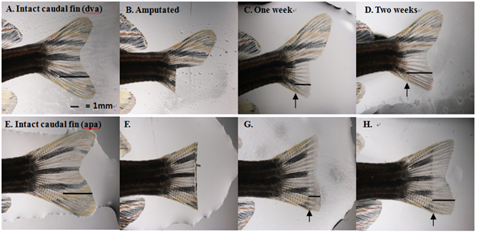
Figure 1. Zebrafish caudal fin regeneration in 2 weeks. The fin cut along the dorsal and ventral axis (dva) with the dorsal portion removed regenerated faster than the fin with the cut along the anterior and posterior axis (apa) with the distal part removed. The straight line represents the fin growth. The arrows are pointing to the start of the regenerated area.

Table 1. The measurement of zebrafish regeneration in 2 weeks showed the Anterior/Posterior cut regrew faster than the Dorsal/Ventral cut.
 | Length of fin cut | Regenerated fin  in one week | Regenerated fin  in two weeks
Anterior/Posterior cut | 4.3 mm | 1.73 mm | 3.4 mm (1.67mm)
Dorsal/Ventral cut | 3.73 mm | 1.4mm | 2.76 mm (1.36mm)
*Measurement of regeneration fin was measured from the point where the cut had made

Answers:

- What do these results indicate?
As shown in Table 1, the zebrafish fin was regenerated faster along the anterior/ posterior axis than the dorsal/ventral axis.

- Was the hypothesis supported or refuted? Why?
Our hypothesis for the zebrafish fin-cut regeneration experiment was supported since the fin that was cut by amputating the distal portion of the fin along the anterior and posterior axis regenerated faster than the fin that was cut along the midline between the dorsal and ventral axis with the dorsal portion removed.

Hypothesis 2: The rate of regeneration of the zebrafish caudal fin will be the same no matter how much cell mass is left at the amputated area.

Questions to consider:
- What will the results look like if our hypothesis is supported?
- If it’s not?

Results:
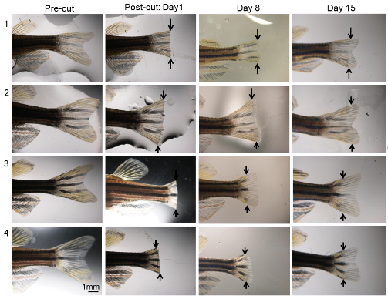
Figure 2: Zebrafish caudal fin regeneration based on different cell masses left after cuts. Zebrafish 1 and 2 had small parts of their caudal fins removed along the dorsal-ventral axis. Zebrafish 3 and 4 had big parts of their caudal fins removed. The caudal fins regrew at different rates, and the regeneration was documented over 3 weeks.

Table 2: The measurement of zebrafish caudal fins from the proximal amputated area to distal end of the fin along the anterior posterior axis and the percentage of regeneration of the fin relative to its original size.
 | Pre-cut (Original length) | Day 1 | Day 8 | Day 15
Zebrafish 1 (small cut) | 5mm | 3mm (0%) | 3.2mm (10%) | 4mm(50%)
Zebrafish 2 (small cut) | 5.5mm | 3.3mm (0%) | 4mm (35%) | 5mm (85%)
Zebrafish 3  (big cut) | 6.0mm | 1.5mm (0%) | 2.8mm (29%) | 4.1mm (58%)
Zebrafish 4  (big cut) | 5.0mm | 2.0mm (0%) | 2.5mm (17%) | 3.8mm (60%)

Answers:

Expected outcomes: If our hypothesis is true, the fins should grow from proximal to distal at the same rate for both big cuts and small cuts. If the hypothesis is false, the fins should fuse from lateral to midline in both cuts.

What do these results mean?
In table 2, zebrafish 2 with the small cut had the fastest regeneration because it recovered 85% of its original fin length. In contrast to zebrafish 2, zebrafish 1, which also had a small cut, only recovered 50% of its fin relative to its original length. Zebrafish 3 and 4, both with big cuts, had similar regeneration rates with Zebrafish 3’s fin recovering 58% of its original length and Zebrafish 4’s fin recovering 60% of its original length.

Was the hypothesis supported or refuted? Why?
The hypothesis was neither supported nor refuted because there was no clear distinction between the rate of regeneration for small cuts versus large cuts. The rate of fin regeneration should have been the same regardless of how much of the fin was left after the cuts in order to support the hypothesis. To refute the hypothesis completely, zebrafish with either small cuts or large cuts should have had faster regeneration rates than the other. The data in this experiment did not follow either scenario to support or refute the hypothesis.

Conclusions:
These are two examples of an experiment designed to test the regeneration process in the caudal fin of zebrafish. If you want to try this experiment yourself and make your own fin clips to test new hypotheses, refer to the Zebrafish Fin Regeneration Experiment in the classroom section.

